Install Python, pycharm, enable plugin intellibot,

Pip install robotframework

pip install robotframework-seleniumlibrary

**Project Structure:**

**Create Basic structure:**

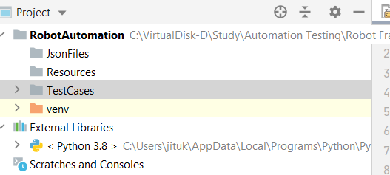

**File Extension**

Test Case File: . robot

Python file> .py

Select the Base Python for all library to be import

Two spaces between keywords and values

Between keyword one space

Chrome driver for chrome 115 is:

<https://edgedl.me.gvt1.com/edgedl/chrome/chrome-for-testing/115.0.5790.170/win64/chromedriver-win64.zip>

CSS Element Locator:

With id:

* CSS = #ID (we are referring to the value of id attribute) or
* CSS = tag#id > input#email
* CSS = .classname (value of class)
* Use any attribute> [attribute=’value’] > [type=’value’] or [name=’value’]
* Use Tag with any attribute – input[id=’value’]
* Id with any attribute **#email[type=’password’]**
* Tag with id with any attribute > **input# email[type=’password’]**
* Use class with any attribute of the element > **.inputtext[type=’email’]**
* Use tag with class with any attribute: **input.classname[type=’pass’]**

For e.g.: #email

https://www.w3schools.com/css/css_selectors.asp:>

|  |  |  |
| --- | --- | --- |
| **Selector** | **Example** | **Example description** |
| [#*id*](https://www.w3schools.com/cssref/sel_id.asp) | #firstname | Selects the element with id="firstname" |
| [.*class*](https://www.w3schools.com/cssref/sel_class.asp) | .intro | Selects all elements with class="intro" |
| [*element.class*](https://www.w3schools.com/cssref/sel_element_class.asp) | p.intro | Selects only <p> elements with class="intro" |
| [*](https://www.w3schools.com/cssref/sel_all.asp) | * | Selects all elements |
| [*element*](https://www.w3schools.com/cssref/sel_element.asp) | p | Selects all <p> elements |
| [*element,element,..*](https://www.w3schools.com/cssref/sel_element_comma.asp) | div, p | Selects all <div> elements and all <p> elements |

**Locate Element with X-Path:**

Always starts with //, Looks for the attribute which is static.

* //tagname[@singleattribute=’value’]

//input[@id='email']

* Use Multiple attributes with or condition

//input[@name=’firstname’ or @area-label=”first name”] # or is case sensitive

* Use Multiple attributes with AND condition

//input[@name=’firstname’ and @area-label=”first name”]

**Fetch and Validate JSON response:**

**Data Driven Testing:**